**ACTIVITY**

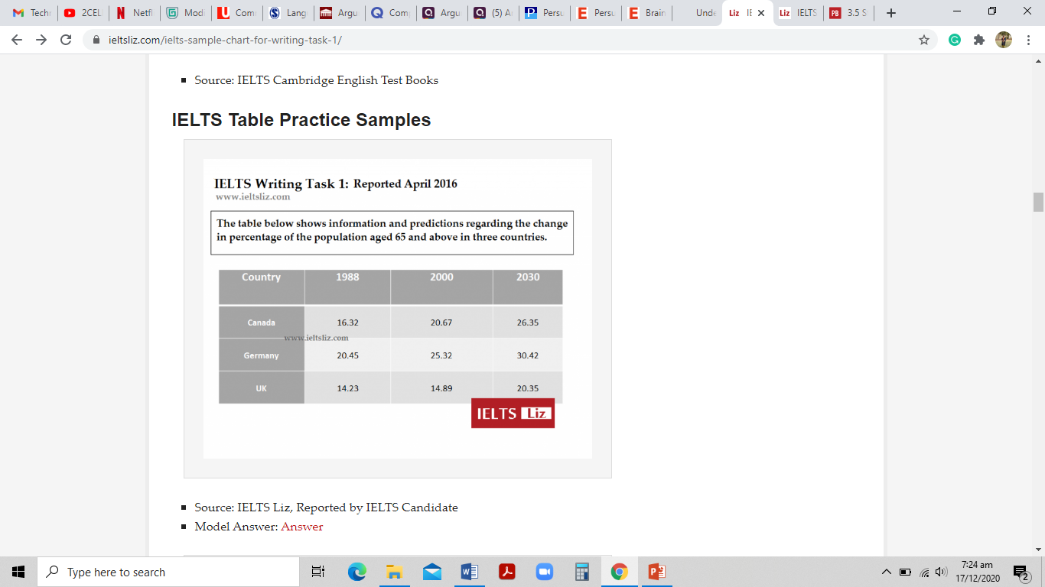

**Tips:**

1. Identify the trends
2. Take notes for the years, countries mentioned
3. Focus on the percentages
4. Choose words (according to the increase, decrease in the pattern)
5. Divide your paragraph after logical sequencing

**Write a short report on the given image. (Word count: 250-300)**

|  |
| --- |
|  |